Chapter 11, Problem 74.

A 120-V rms 60-Hz source supplies two loads connected in parallel, as shown in Fig. 11.89.
- Find the power factor of the parallel combination.
- Calculate the value of the capacitance connected in parallel that will raise the power factor to unity.

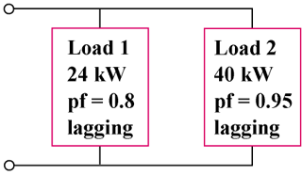

Figure 11.89
For Prob. 11.74.

